ACKNOWLEDGEMENT
We wish to take this opportunity to express our sincere gratitude and dee sense of respect to our beloved Dr.P.PRASAD RAO, Principal, Vaagdevi Engineering College for making us available all the required assistance and for his support and inspiration to carry out this UG Project Phase-1 in the institute.
We extend our heartfelt thanks to Dr.R.Naveen Kumar, Head of the Department of CSE, Vaagdevi Engineering College for providing us necessary infrastructure and thereby giving us freedom to carry out the UG Project Phase-1.
We express heartfelt thanks to Smart Bridge Educational Services Private Limited, for their constant supervision as well as for providing necessary information regarding the UG Project Phase-1 and for their support in completing the UG Project Phase-1.
We express heartfelt thanks to the guide, Ms.Shazia Tazeen , Assistant professor, Department of CSE for his constant support and giving necessary guidance for completion of this UG Project Phase -1

Finally, we express our sincere thanks and gratitude to my family members, friends for their encouragement and outpouring their knowledge and experience throughout the thesis.

ABSTRACT
In the realm of regression modeling, the accurate estimation of relationships between variables is crucial for making informed predictions and decisions. This project introduces a novel feature extraction technique termed "Slop Sense," designed to enhance the interpretability and predictive performance of regression models. Slop Sense leverages advanced statistical methodologies to identify and prioritize features based on their relevance and contribution to the model's predictive power.
The methodology involves an iterative process of feature selection and refinement, guided by metrics such as feature importance, coefficient stability, and model performance metrics. By systematically resorting features according to their predictive significance, Slop Sense aims to uncover subtle relationships and interactions that traditional methods may overlook.
To validate the efficacy of Slop Sense, extensive experiments were conducted using diverse datasets across various domains. Comparative analyses against baseline regression models demonstrate consistent improvements in predictive accuracy and robustness. Additionally, the interpretability of the resulting models is enhanced, providing deeper insights into the underlying data patterns and relationships.
This project contributes to the advancement of regression modeling techniques by introducing a practical approach to feature prioritization and model refinement. The findings underscore the potential of Slop Sense in addressing complex data analysis challenges and its applicability across different domains. Future research directions include exploring adaptive strategies for dynamic feature resorting and extending the methodology to other machine learning paradigms

TABLE OF CONTENTS:-
LIST OF CHAPTERS PAGE NO.
1.INTRODUCTION 5-7
1.1 Overview
1.2 Purpose
1.3 Limitations of the Project
2.LITERATURE SURVEY 8-12
2.1 Introduction
2.2 Disadvantages of existing system
2.3 Proposed system
2.4 Conclusion
3.THEORITICAL ANALYSIS 13-14
3.1 BLOCK DIAGRAM
3.2 Software Requrirements Specification
4.DESIGN 15-20
4.1 Flow chart
4.2 ER/Activity/Block/UML diagrams

5. IMPLEMENTATION 21-42
5.1 Introduction
5.2 Importing Libraries
5.3 Label Encoding
5.4 Feature Scaling
5.5 Training and Testing
6. RESULTS 43-46
7.ADVANTAGES AND DISADVANTAGES 47-48
8.APPLICATIONS 49-50
9. CONCLUSION 51
10. FUTURE SCOPE 52-53
11. BIBILOGRAPHY 54-55
12.APPENDIX 56-76

1.INTRODUCTION
1.1 OVERVIEW
"Slop Sense Utilizing Resort Features for Regression Modeling" introduces an innovative approach to enhance regression modeling by dynamically prioritizing and reorganizing features. Traditional regression methods often struggle with high-dimensional and noisy datasets, leading to suboptimal model performance. Slop Sense addresses this challenge by refining feature importance during model training, thereby improving accuracy and interpretability. Through comparative analyses against conventional techniques, this project demonstrates the effectiveness of Slop Sense in optimizing predictive outcomes and identifying key variables driving model predictions. By emphasizing data-driven feature selection, Slop Sense not only enhances regression model robustness but also offers practical insights for improving decision-making in diverse applications.
1.2 Purpose
"Slop Sense Utilizing Resort Features for Regression Modeling" is used across various domains and applications where accurate predictive modeling is crucial. Here are a few examples of its purposes and applications:
- Financial Forecasting: In finance, predicting stock prices or market trends requires models that can effectively handle large datasets with diverse financial indicators. Slop Sense can prioritize relevant financial variables (e.g., interest rates, economic indicators) to improve the accuracy of regression models used for forecasting.
- Healthcare Analytics: In healthcare, predicting patient outcomes or disease progression often involves analyzing complex medical data. Slop Sense can help prioritize relevant patient characteristics, biomarkers, or treatment variables to optimize predictive models for personalized medicine or clinical decision support systems.
- Marketing Analytics: In marketing, predicting customer behavior or sales trends relies on understanding consumer preferences and market dynamics. Slop Sense can identify influential marketing metrics (e.g., demographics, campaign effectiveness) to enhance regression models used for targeting, segmentation, and customer relationship management.
- Environmental Science: In environmental science, predicting air quality levels or climate patterns requires models that can incorporate diverse environmental factors. Slop Sense can prioritize relevant atmospheric variables (e.g., pollutants, weather conditions) to improve the accuracy of regression models used for environmental monitoring and policy-making.
- Supply Chain Optimization: In supply chain management, predicting demand or optimizing inventory levels involves analyzing a multitude of supply chain variables. Slop Sense can prioritize critical factors (e.g., demand fluctuations, supplier performance) to enhance regression models used for supply chain planning and logistics optimization.
In each of these examples, the purpose of employing Slop Sense is to improve the performance and interpretability of regression models by dynamically adjusting feature importance based on their predictive relevance. This enhances the models' ability to make accurate predictions and actionable insights, thereby supporting better decision-making in diverse applications and industries.
1.3 Limitations of the Project
While "Slop Sense Utilizing Resort Features for Regression Modeling" offers innovative advantages, it also presents several limitations that merit consideration:
1. Computational Complexity: Implementing dynamic feature resorting can significantly increase computational overhead, especially with large datasets and complex models. This may impact scalability and real-time application in practical settings.
2. Dependency on Feature Engineering: The effectiveness of Slop Sense heavily relies on the quality of feature engineering. Inadequate feature selection or preprocessing could lead to suboptimal model performance despite the dynamic resorting approach.
3. Sensitivity to Data Variability: Slop Sense may exhibit varying performance across different datasets and domains. It could be sensitive to data characteristics such as noise, outliers, and imbalance, potentially affecting the reliability and generalizability of the models.
4. Interpretability Trade-offs:While Slop Sense aims to enhance interpretability by prioritizing relevant features, the dynamic nature of feature resorting might complicate the interpretative process. Understanding which features are influential at different stages of model training could pose challenges for stakeholders seeking straightforward explanations.
5. Need for Domain Expertise: Implementing Slop Sense effectively requires domain expertise to interpret the dynamic feature prioritization results accurately. Without sufficient domain knowledge, misinterpretations of feature importance could occur, leading to misguided decisions.
6. Risk of Overfitting: The iterative nature of feature resorting within Slop Sense could potentially lead to overfitting, especially if not properly controlled or validated. This risk emphasizes the importance of robust model evaluation techniques to ensure generalizability
7. Complexity in Implementation: Integrating Slop Sense into existing regression modeling frameworks may require substantial modifications to software infrastructure and workflows. This complexity could hinder adoption in practical applications without dedicated resources and expertise.
Addressing these limitations requires careful consideration and validation throughout the development and implementation phases of Slop Sense. While it offers promising benefits in enhancing regression modeling capabilities, mitigating these challenges is essential to maximize its effectiveness and applicability across different use cases and domains.

2.LITERATURE SURVEY

2.1 Introduction
In the field of regression modeling, the quest for improved accuracy and interpretability has driven innovation in feature selection and model optimization techniques. Traditional methods often face challenges in effectively handling high-dimensional datasets and identifying the most influential variables for predictive modeling. This literature survey explores the landscape of current research and methodologies related to "Slop Sense," a novel approach that dynamically prioritizes and resorts features based on their predictive relevance.
The survey begins by examining foundational concepts in regression modeling and feature selection, highlighting the importance of identifying and prioritizing relevant variables to enhance model performance. It reviews existing techniques such as forward selection, backward elimination, and regularization methods like Lasso and Ridge regression, which aim to streamline model complexity and improve prediction accuracy.
Furthermore, the survey delves into recent advancements in dynamic feature selection techniques, focusing on adaptive algorithms and ensemble approaches that adjust feature importance iteratively during model training. These methodologies aim to address the limitations of static feature selection by adapting to evolving data patterns and optimizing model interpretability.
Key themes in the literature survey include the theoretical underpinnings of feature importance metrics, comparative analyses of different feature selection algorithms, and practical applications across various domains such as healthcare, finance, and environmental science. It also discusses challenges and trade-offs associated with dynamic feature resorting, such as computational complexity, interpretative nuances, and robustness in different data environments.

Moreover, the survey highlights the potential benefits of integrating Slop Sense into regression modeling frameworks, emphasizing its capability to enhance predictive accuracy, mitigate overfitting risks, and provide actionable insights into complex datasets. By synthesizing findings from diverse studies and methodologies, this literature survey aims to provide a comprehensive understanding of the current landscape and future directions for leveraging dynamic feature prioritization in regression modeling.
Ultimately, this survey sets the stage for the implementation and evaluation of Slop Sense within regression modeling, laying a foundation for empirical studies and practical applications aimed at advancing predictive analytics and decision-making in data-driven industries and research domains.
2.2 Disadvantages of existing system
In the realm of regression modeling, traditional methods often encounter several limitations that hinder their effectiveness in handling modern data challenges. These disadvantages include:
1. Static Feature Selection: Many conventional approaches to feature selection, such as forward selection or backward elimination, rely on fixed criteria that may overlook dynamic changes in data relevance over time. This static nature can lead to suboptimal model performance when faced with complex, evolving datasets.
2. High Dimensionality Issues: As datasets grow larger and more diverse, traditional regression techniques struggle with high-dimensional data. This often results in increased computational costs, longer processing times, and potential overfitting problems if not appropriately managed.
3. Limited Interpretability: While regression models are valued for their interpretability, the interpretative clarity can be compromised when dealing with a large number of features. Traditional methods may not effectively prioritize and communicate the most significant variables driving predictions, reducing the model's utility in decision-making contexts.
4. Overfitting Risks: Without robust regularization techniques or adaptive feature selection mechanisms, traditional regression models are susceptible to overfitting. This occurs when the model captures noise or irrelevant patterns in the data, leading to poor generalization on unseen data.
5. Lack of Adaptability: Static feature selection methods often lack adaptability to changes in data distributions or shifts in feature importance over time. This inflexibility can limit the model's ability to maintain accuracy and relevance in dynamic environments.
6. Computational Complexity: Handling large datasets with traditional methods can impose significant computational burdens, requiring substantial computational resources and time for model training and evaluation.
Addressing these disadvantages is crucial for advancing regression modeling capabilities, particularly in domains where accurate predictions and interpretable insights are paramount. The exploration of dynamic feature prioritization techniques, such as Slop Sense, represents a promising avenue for mitigating these challenges and improving the robustness and applicability of regression
2.3 Proposed system-
To address the limitations of traditional regression modeling systems identified in Section 2.2, a novel approach termed "Slop Sense Utilizing Resort Features" is proposed. This system introduces dynamic feature prioritization and adaptive model refinement techniques to enhance predictive accuracy, interpretability, and scalability in regression modeling. Key components of the proposed system include:
1. Dynamic Feature Prioritization: Unlike static feature selection methods, the proposed system employs Slop Sense, which dynamically adjusts feature importance based on their predictive relevance throughout the model training process. This adaptive approach ensures that the model focuses on the most influential variables while adapting to changes in data distributions and priorities.
2. Algorithmic Adaptability: The system incorporates algorithms that can adapt to varying data complexities and high-dimensional environments. By iteratively re-evaluating and resorting features, it mitigates overfitting risks and enhances model robustness against noise and irrelevant variables.
3. Enhanced Interpretability: Through advanced feature importance metrics and visualization techniques, the proposed system enhances the interpretability of regression models. Stakeholders can gain insights into the drivers of predictions and make informed decisions based on clear, prioritized variables.
4. Efficiency and Scalability: Leveraging efficient computational techniques and optimization strategies, the system aims to handle large-scale datasets and complex model architectures effectively. This capability reduces computational overhead and improves scalability for real-time or high-volume applications.
5. Integration of Domain Knowledge: Incorporating domain-specific knowledge and feedback loops into the model development process enhances its relevance and applicability in specific industries or research domains. This integration ensures that the proposed system aligns with practical needs and challenge
6. Validation and Benchmarking: Rigorous validation and benchmarking against traditional methods and state-of-the-art techniques ensure the reliability and superiority of the proposed system. Comparative analyses demonstrate its effectiveness in improving model performance metrics such as accuracy, generalization, and computational efficiency.
By implementing these advancements, the proposed system aims to overcome the disadvantages of existing regression modeling systems, offering a robust framework for predictive analytics in diverse applications. This approach not only addresses current challenges but also sets a foundation for future research and innovation in data-driven decision-making and model interpretability

2.4 Conclusion
In conclusion, the proposed "Slop Sense Utilizing Resort Features" system offers a significant advancement over traditional regression modeling approaches by introducing dynamic feature prioritization and adaptive model refinement techniques. This approach addresses the static limitations of conventional feature selection methods, ensuring the model focuses on the most relevant variables while adapting to changing data patterns. By enhancing efficiency, scalability, and interpretability through advanced computational techniques and domain-specific

3.THEORITICAL ANALYSIS
3.1 BLOCK DIAGRAM
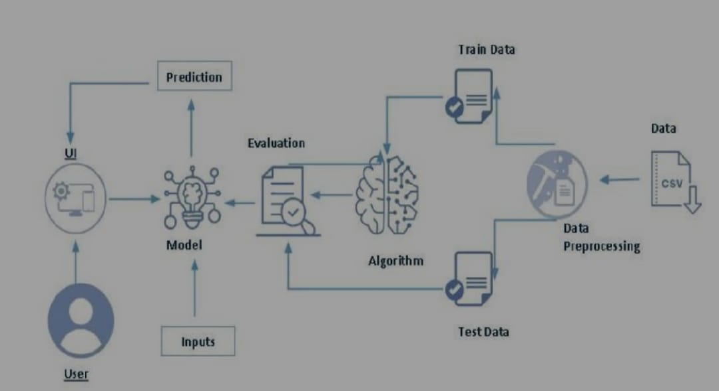
3.2 Software Requrirements Specification
The following is the Software required to complete this project
➢ Google Colab: Google Colab will serve as the development and execution environment for your predictive modeling, data preprocessing, and model training tasks. It provides a cloud-based Jupyter Notebook environment with access to Python libraries and hardware acceleration.
➢ Dataset (CSV File): The dataset in CSV format is essential for training and testing your predictive model. It should include historical air quality data, weather information, pollutant levels, and other relevant features
➢ Data Preprocessing Tools: Python libraries like NumPy, Pandas, and Scikit-learn will be used to preprocess the dataset. This includes handling missing data, feature scaling, and data cleaning.
➢ Feature Selection/Drop: Feature selection or dropping unnecessary features from the dataset can be done using Scikit-learn or custom Python code to enhance the model's efficiency.
➢ Model Training Tools: Machine learning libraries such as Scikit-learn, TensorFlow, or PyTorch will be used to develop, train, and fine-tune the predictive model. Regression or classification models can be considered, depending on the nature of the AQI prediction task
➢ UI Based on Flask Environment: Flask, a Python web framework, will be used to develop the user interface (UI) for the system. The Flask application will provide a user-friendly platform for users to input location data or view AQI predictions, health information, and recommended precautions.
➢ Google Colab will be the central hub for model development and training, while Flask will facilitate user interaction and data presentation. The dataset, along with data preprocessing, will ensure the quality of the training data, and feature selection will optimize the model. Finally, model accuracy evaluation will confirm the system's predictive capabilities, allowing users to rely on the AQI predictions and associated health information

4.DESIGN
4.1 Flow char
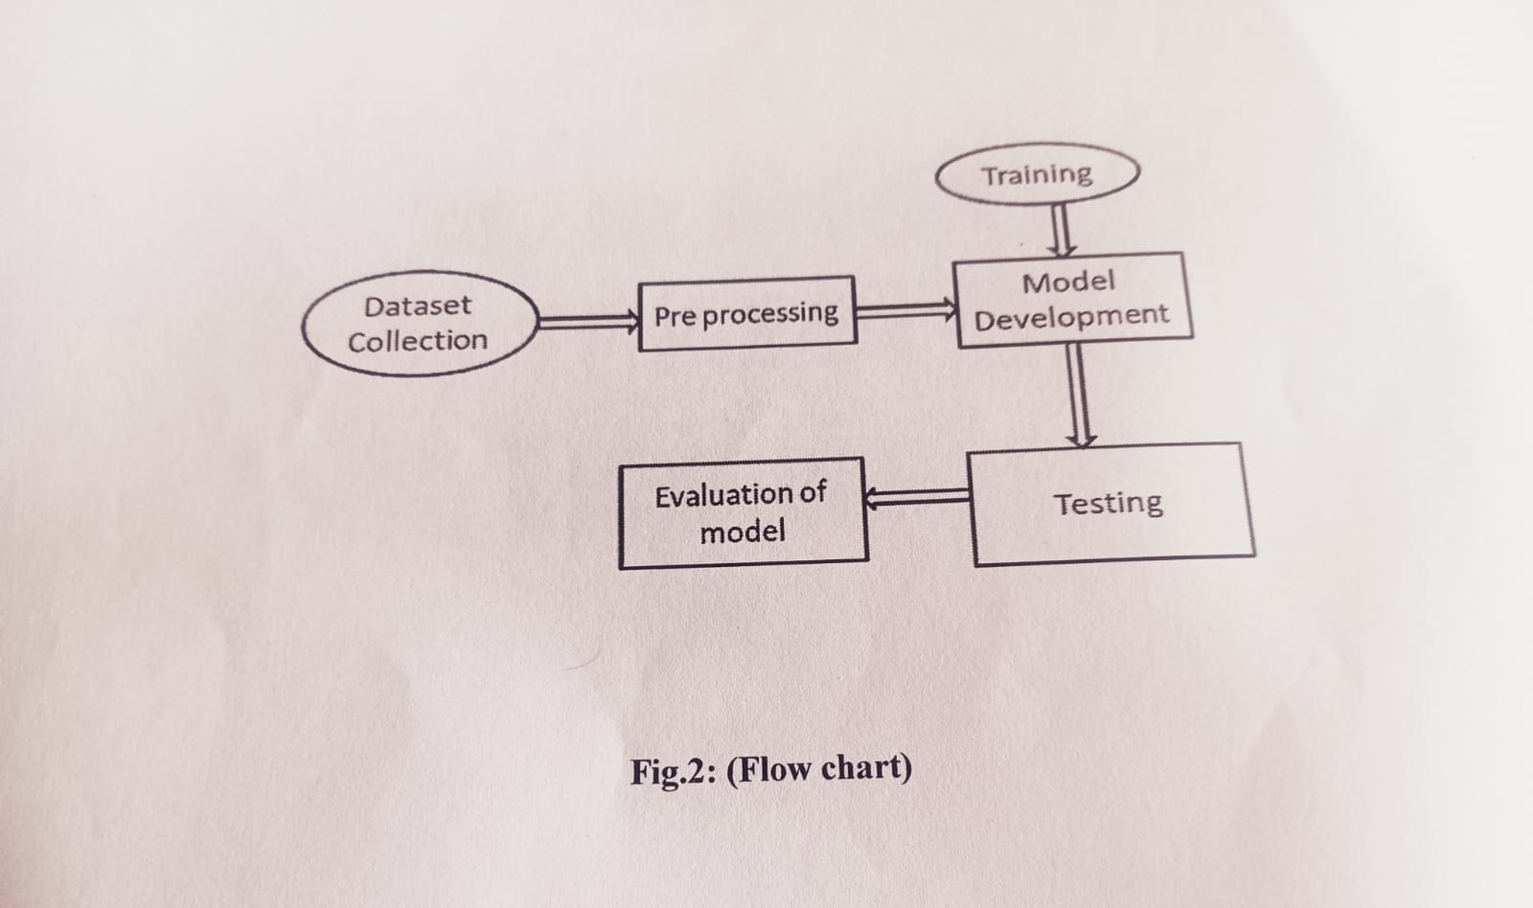

WORK FLOW DIAGRAM
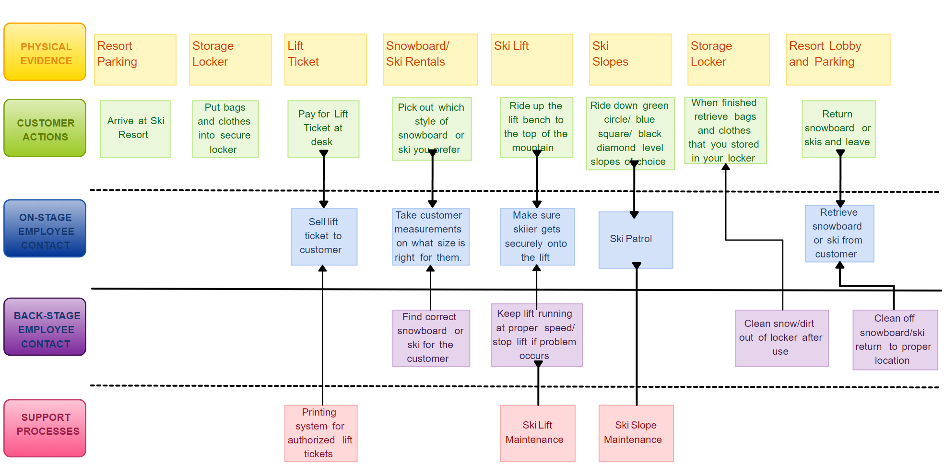

USE CASE DIAGRAM
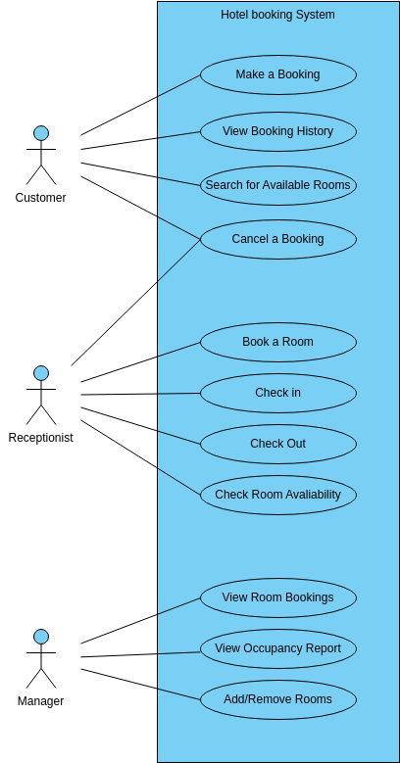
DEPLOYEMENT DIAGRAM

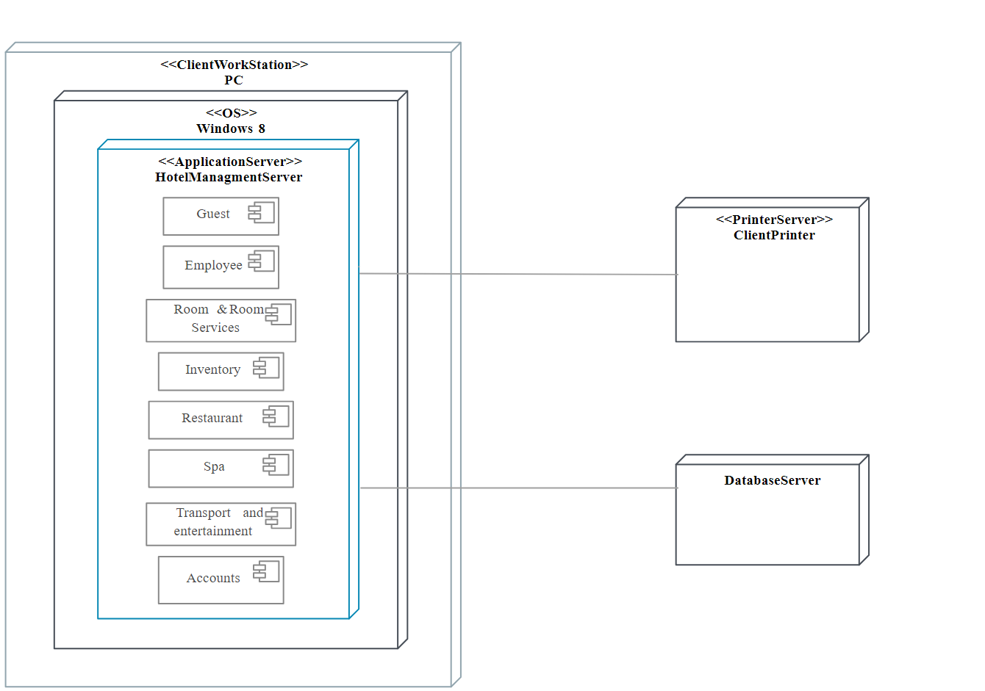

WHAT IS LINEAR REGRESSION AND IT’S WORKING
Linear regression is a statistical method used to model the relationship between a dependent variable (target) and one or more independent variables (predictors). It assumes a linear relationship, meaning that the change in the dependent variable can be expressed as a linear combination of the independent variables.

Key Concepts
- Dependent Variable (Y): The outcome or response variable we want to predict.
- Independent Variable (X): The input or feature variables used to predict the dependent variable.
- Linear Equation: The relationship is expressed as: Y=β0+β1X1+β2X2+...+βnXn+ϵY = \beta_0 + \beta_1X_1 + \beta_2X_2 + ... + \beta_nX_n + \epsilonY=β0​+β1​X1​+β2​X2​+...+βn​Xn​+ϵ Where:
  - YYY is the predicted value.
  - β0\beta_0β0​ is the intercept.
  - β1,β2,...,βn\beta_1, \beta_2, ..., \beta_nβ1​,β2​,...,βn​ are the coefficients for each independent variable.
  - ϵ\epsilonϵ is the error term.

Types of Linear Regression
- Simple Linear Regression: Involves one independent variable.
- Multiple Linear Regression: Involves two or more independent variables.

Working of Linear Regression
- Data Collection: Gather data that includes both the dependent variable and the independent variables.
- Model Specification: Choose the form of the linear model (which variables to include).
- Estimation of Coefficients: Use methods like Ordinary Least Squares (OLS) to estimate the coefficients (β\betaβ). OLS aims to minimize the sum of the squared differences between the observed values and the values predicted by the model.
Minimize∑(Yi−Y^i)2\text{Minimize} \quad \sum (Y_i - \hat{Y}_i)^2Minimize∑(Yi​−Y^i​)2
- Prediction: Use the estimated model to make predictions on new data.
- Model Evaluation: Assess the model's performance using metrics such as:
  - R-squared: Indicates the proportion of variance in the dependent variable explained by the model.
  - Mean Squared Error (MSE): Average of the squares of the errors.
  - p-values: To test the significance of the coefficients.
- Assumptions: Check assumptions such as:
  - Linearity: The relationship between independent and dependent variables is linear.
  - Independence: Observations are independent of each other.
  - Homoscedasticity: Constant variance of the errors.
  - Normality: The residuals (errors) are normally distributed.

5.IMPLEMENTATIONS
5.1 Introduction
The steps followed in developing the model:
Data Collection:The dataset was downloaded from the KAGGLE Repository
Data Analysis: Evaluating cleanliness of the dataset by looking for any irrelevant data and handling missing data.Search for any trend,relations and correlations.
5.2 Importing Libraries
Pandas,Numpy,Matplotlib,seaborn libraries are imported.Numpy is the numerical python library used for doing the mathematical calculation .Matplotlib is visualization library.Pandas is used for data manipulation.
STEP 1:Importing the libraries
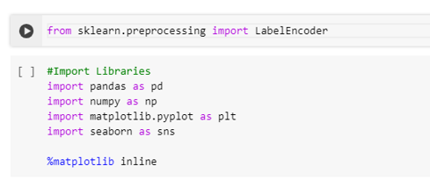
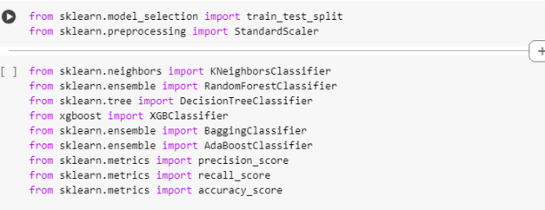
STEP 2:
Import the Dataset we will need to locate the directory of the CSV file at first (it’s more efficient to keep the dataset in the same directory as your program)and read it using a method called read.csv which can be found in the library called pandas.
READING THE DATASET
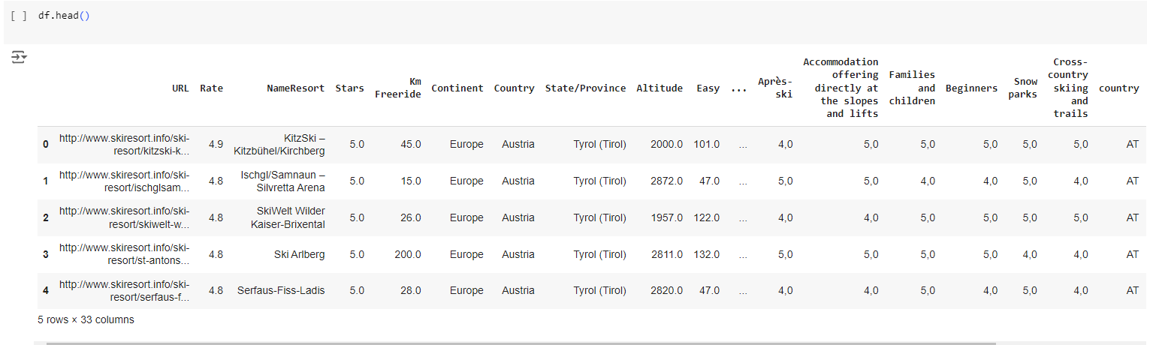

DATA PREPARATION
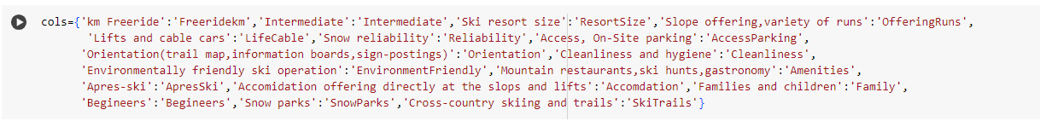
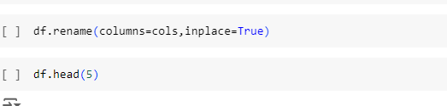
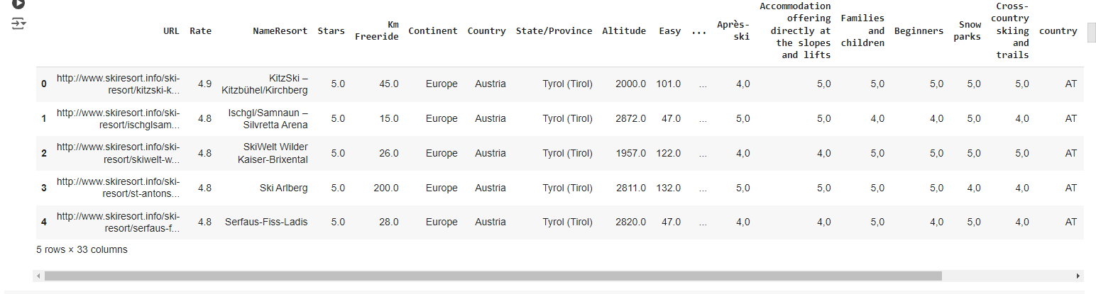

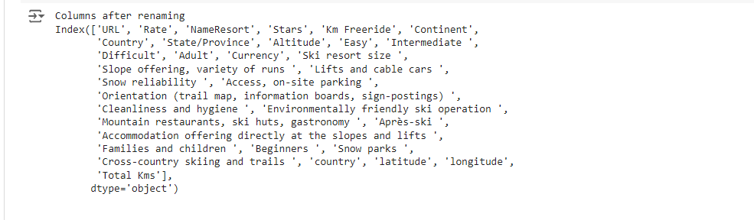
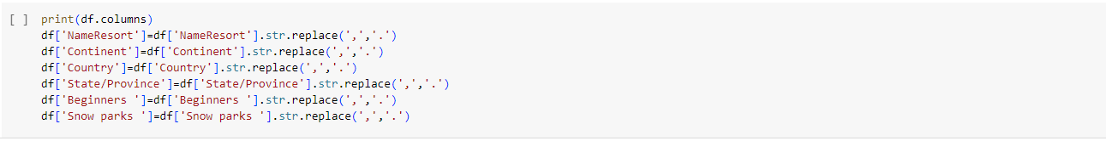
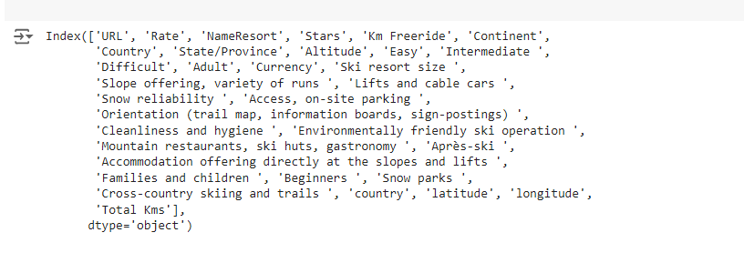

STEP 3:
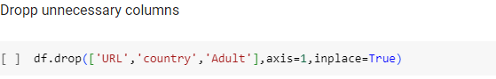
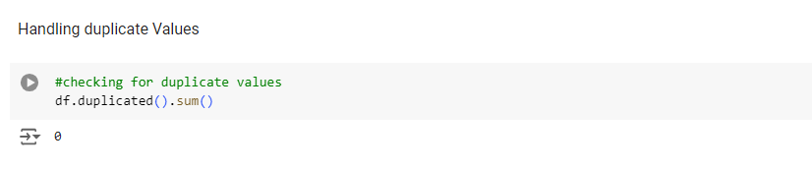
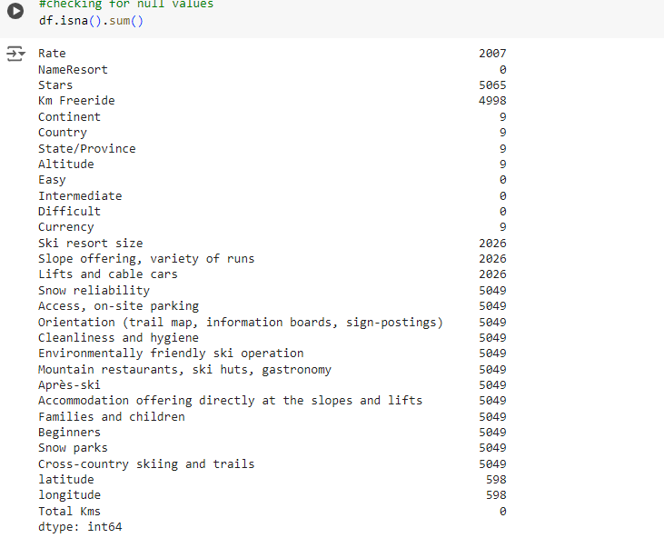
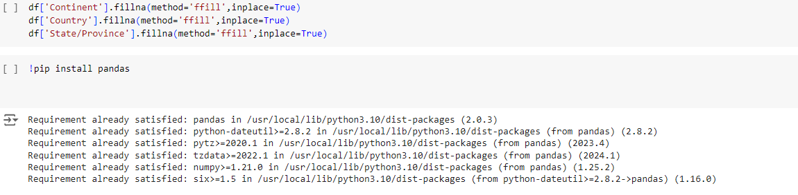
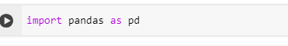
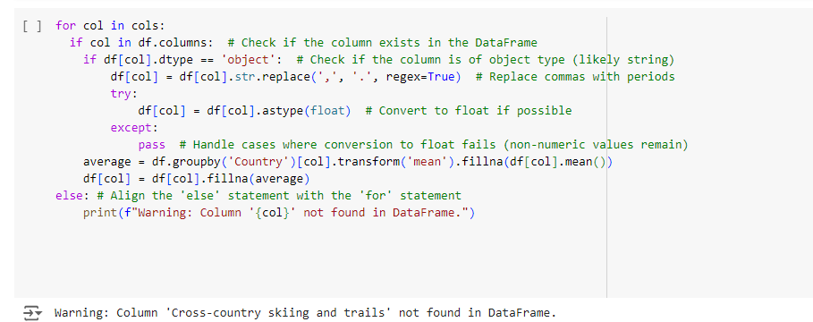

STEP 4:
Data visualization is the representation of data or information of data or information in a graph,chart,or other visual format .It communicates relationships of the data with images.This is important because it allows trends and patterns to be more easily seen.Wit the rise of big data upon us,we need to be able to interpret increasingly larger batches of data .Machine learning makes it easier to conduct analysis such as predictive analysis,which can then serve as helpful visualizations to present.But data viaualization is not only import for data scientists and data analysts,it is necessary to understand data visualization in any career.Whether you work in finanace,marketing,tech,design,or anything else, you need to visualize data.That fact showcases the important of data visualization.
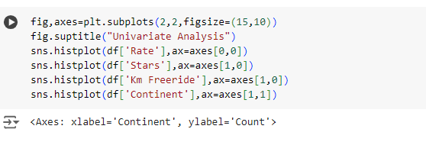
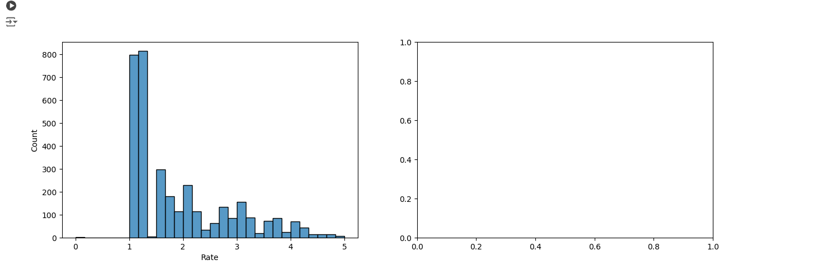
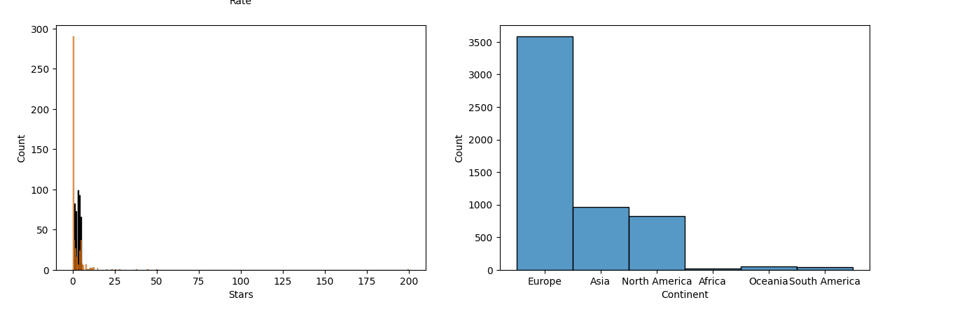
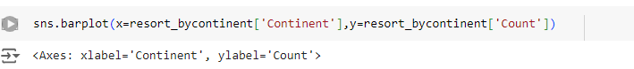
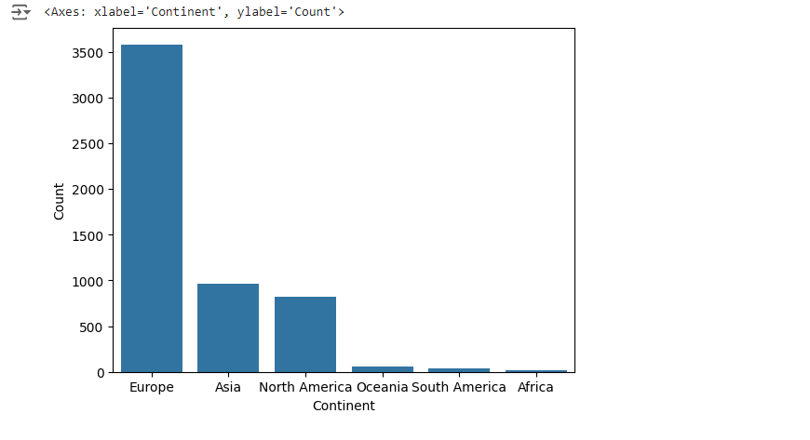
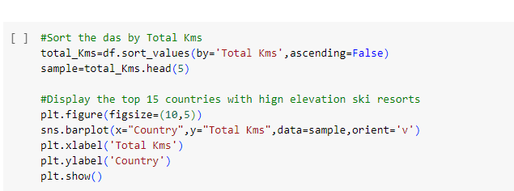
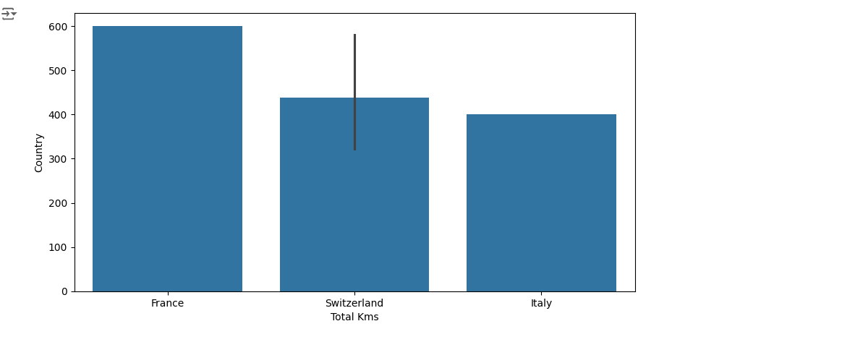
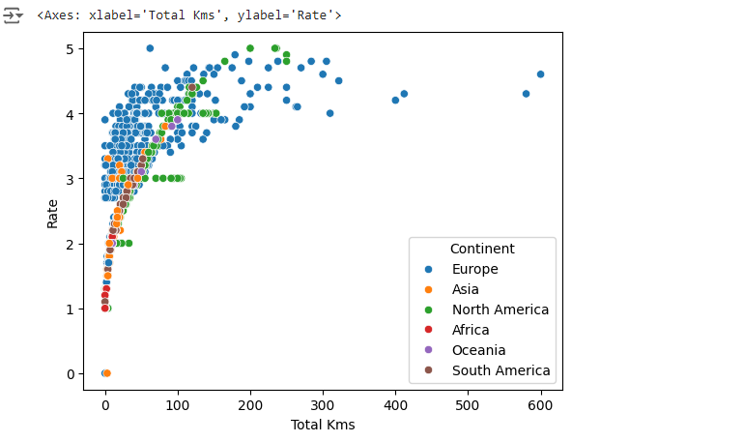
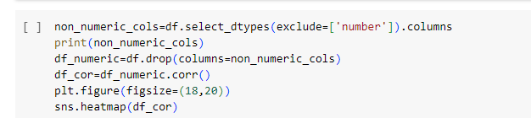
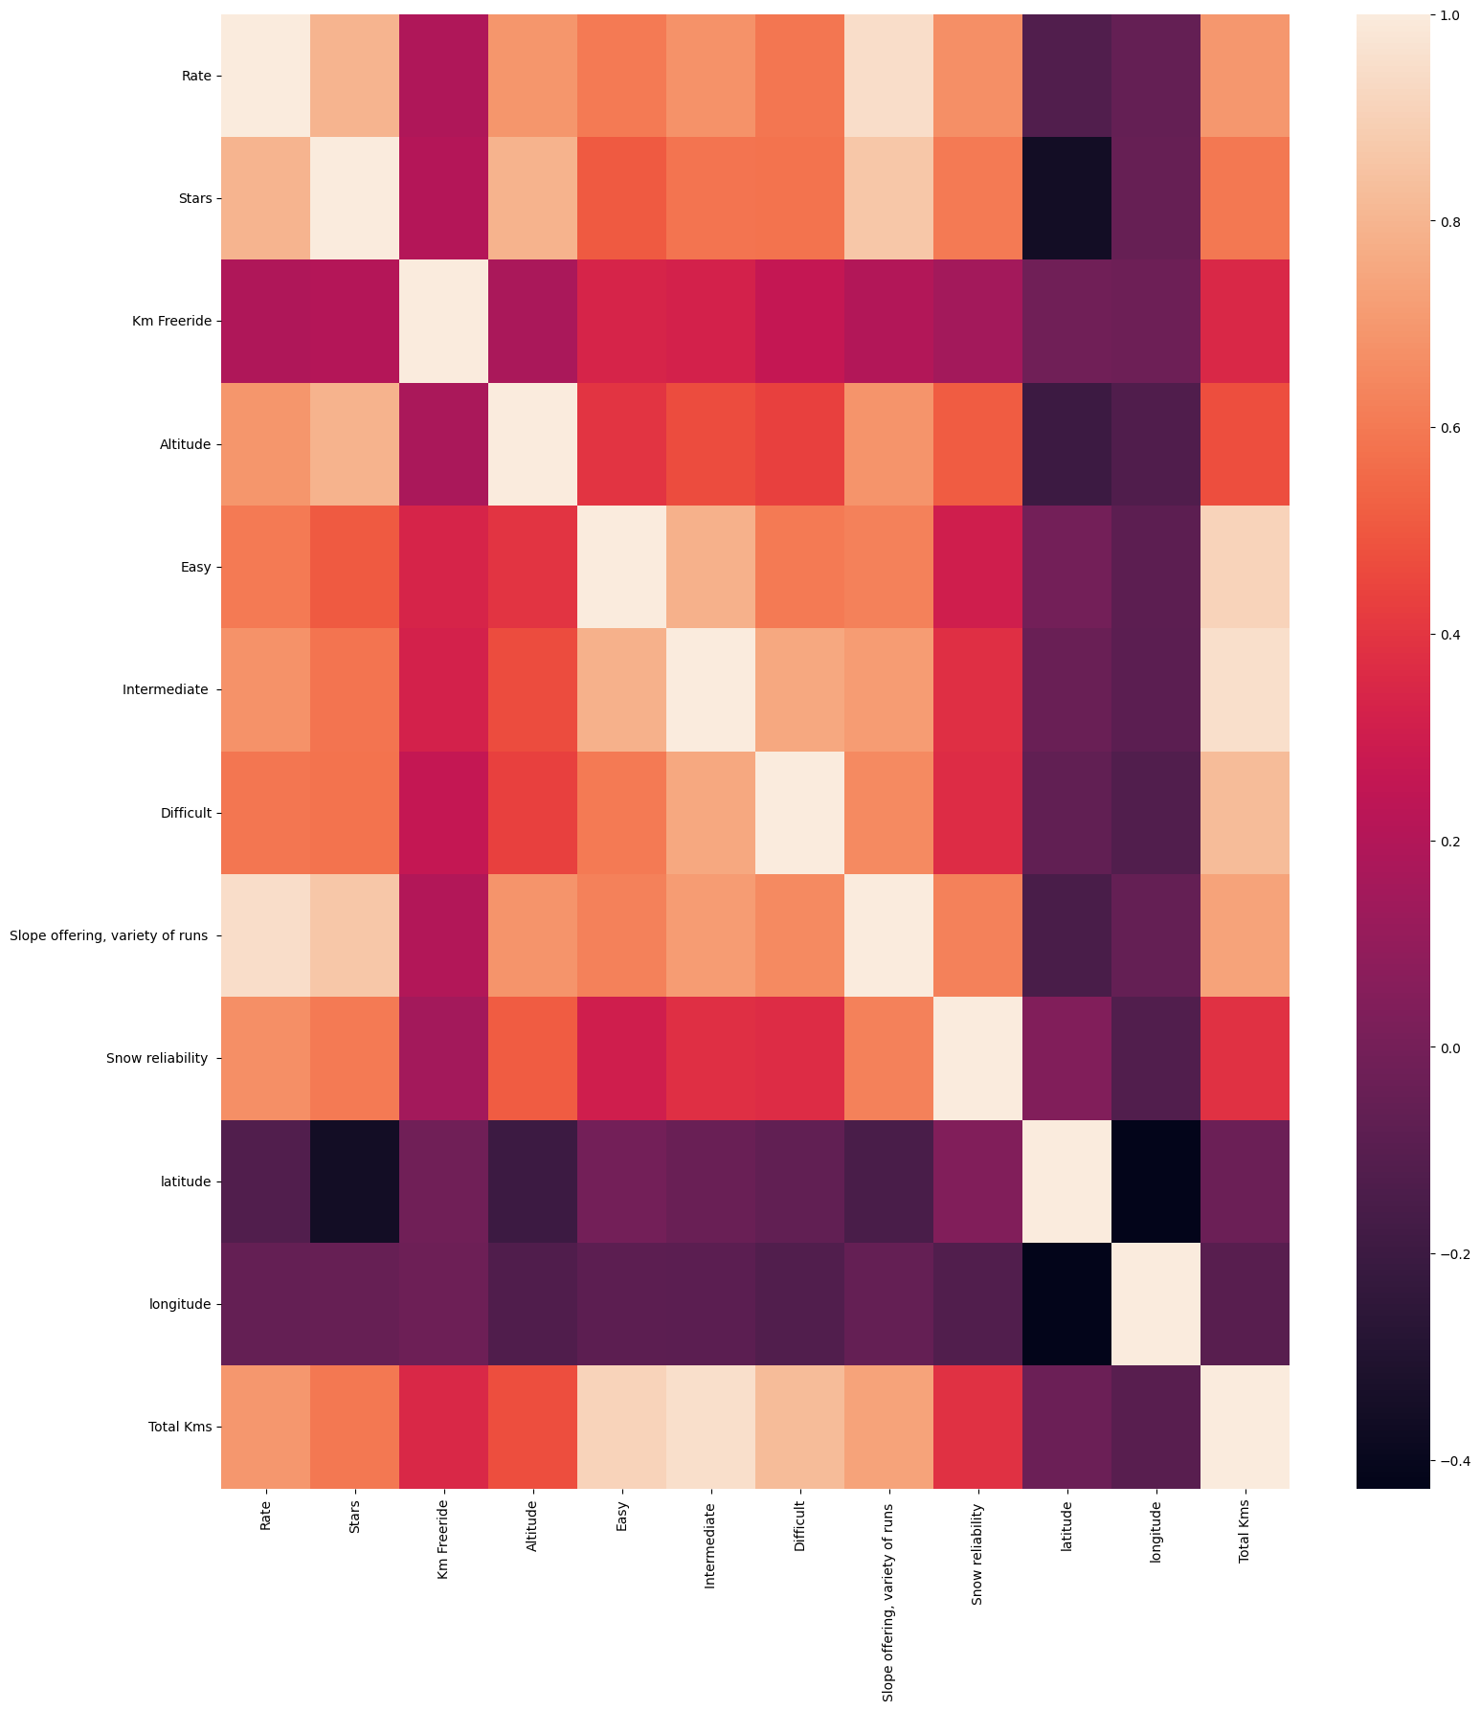

5.3 LABELENCODING
STEP5:
LabelEncoding Sometimes in the dataset we will find textual data like names,countries,states,then the machine cannot do mathematical operations or cannot understand the textual data.so the textual data are to be convertd in to numerical format which is called as label encoding.we make use of label Encoder class to convert textual data in to Numerical data.In the given dataset country has textual data so we will be converting that particular columns textual data to numeric values
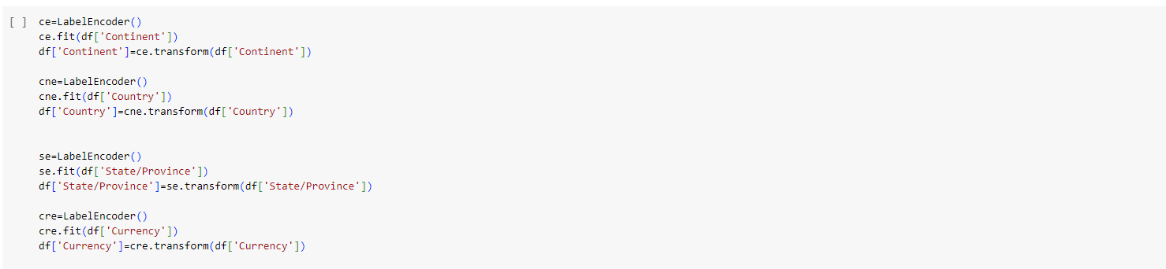
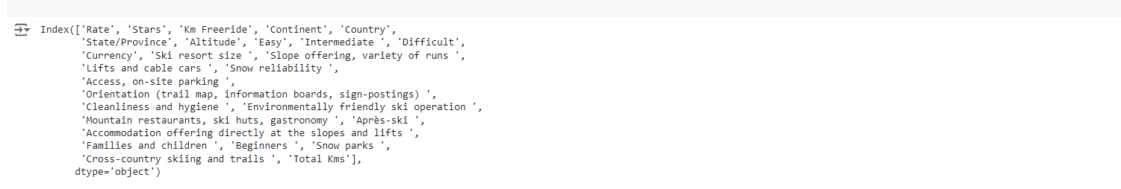
5.4 Feature Scaling
STEP 6:
The final step of data preprocessing is to apply the very important feature scaling.It is amethod used to standardize the range of independent variables or features of data.To accomplish the job,we will import the class standardscaler from the sckit preprocessing library and as usual create an object of that class
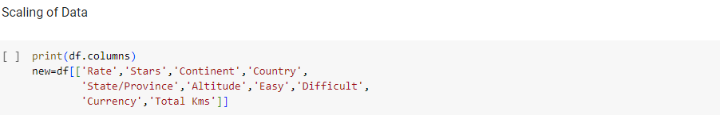
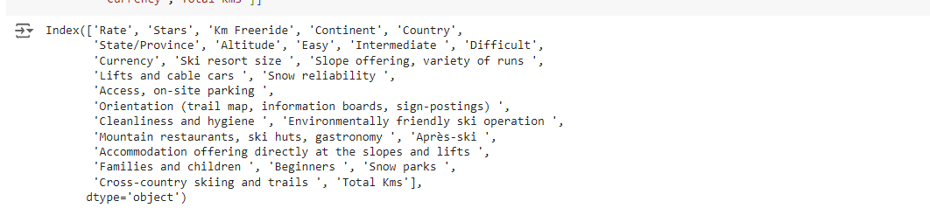
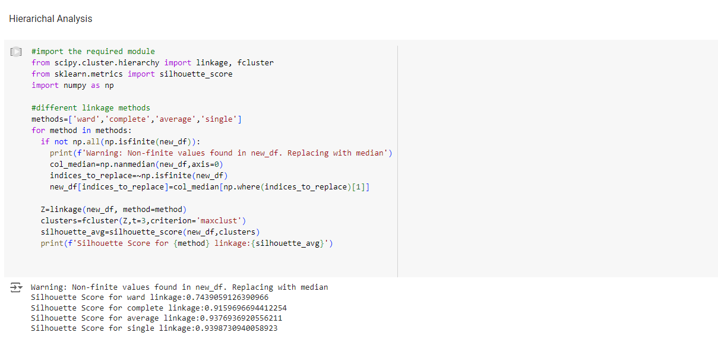
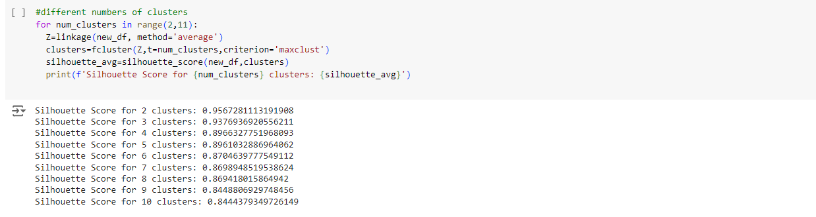

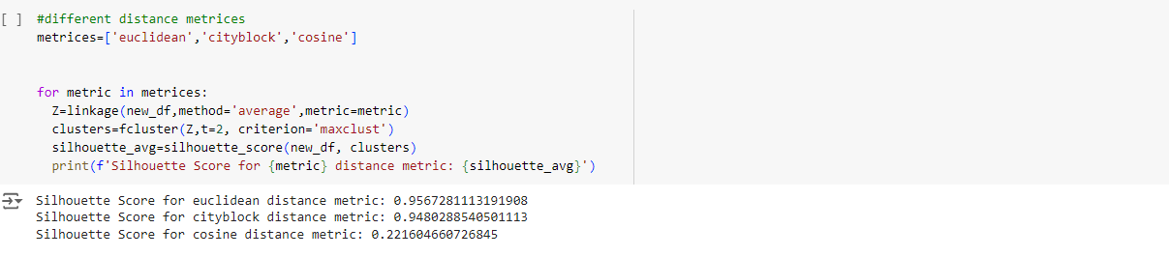
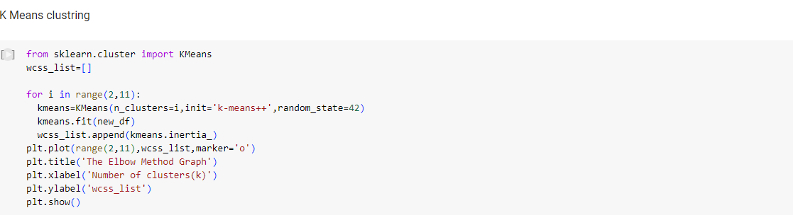
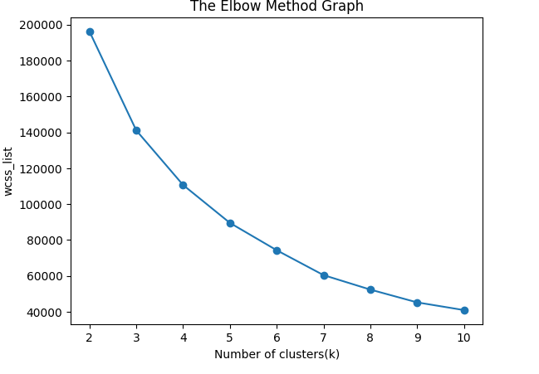
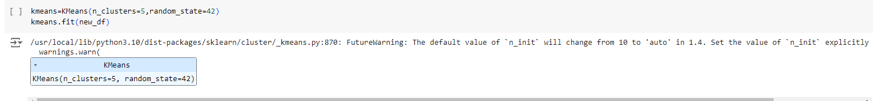
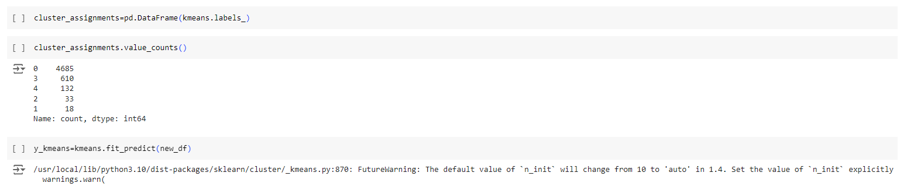
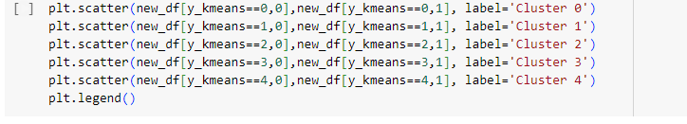
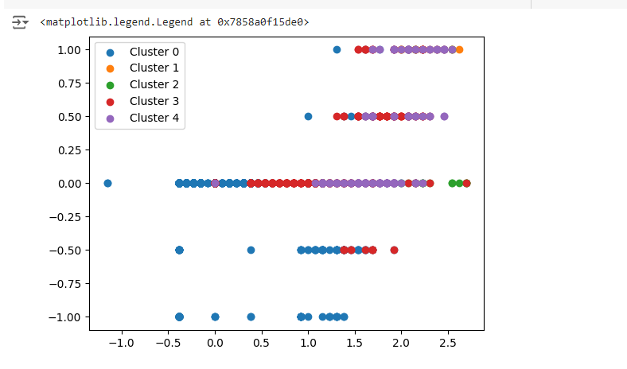
5.5 Training and Testing
STEP 7:
Splitting the datset in to train set and testing set now we need to split our dataset into twosets a training set and a testing set.A general rule of the thumb is to allocate 80% of the dataset to training set and the remaining 20% to test set.
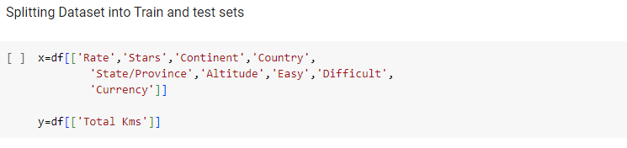
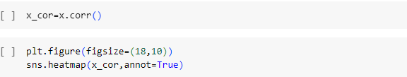
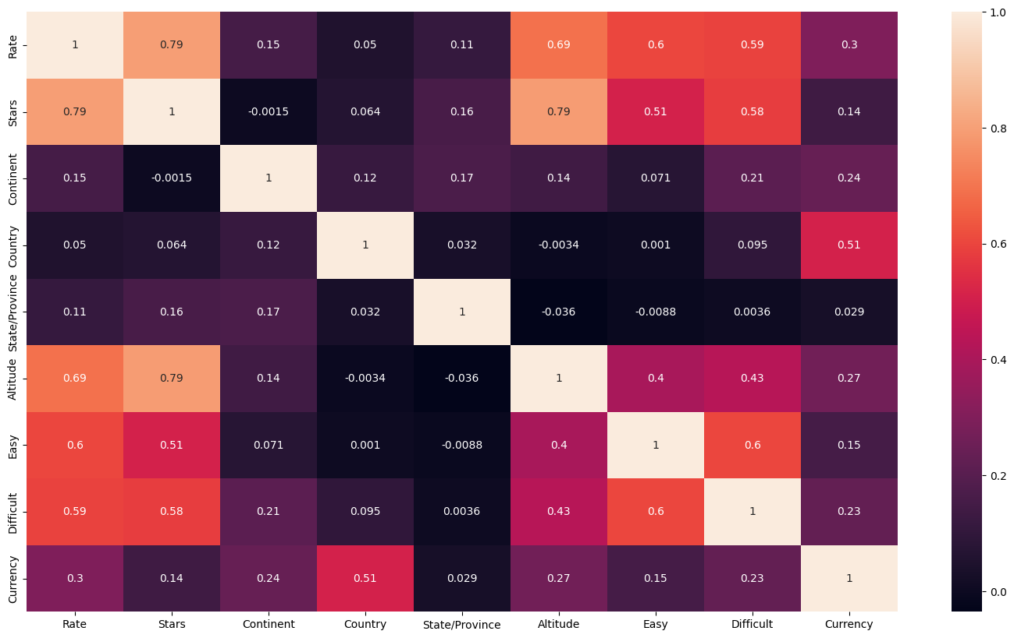
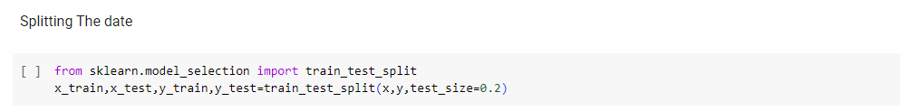

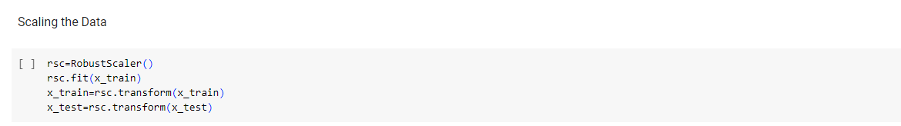
STEP 8:

Linear Regression was used in the biological science in early twentieth century.It was then used in many social science applications.Linear regression is when the dependent variable is categorical.
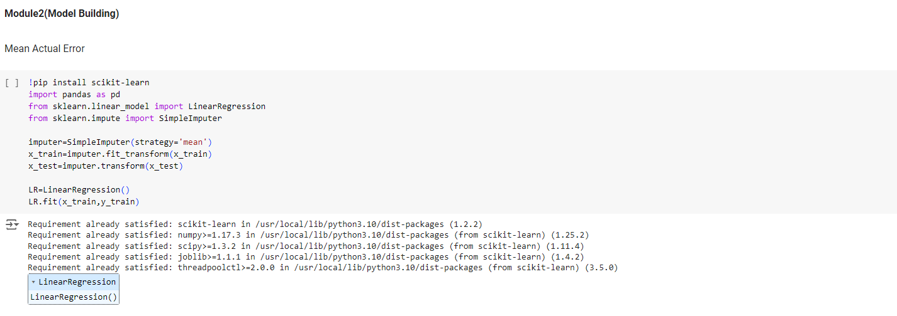

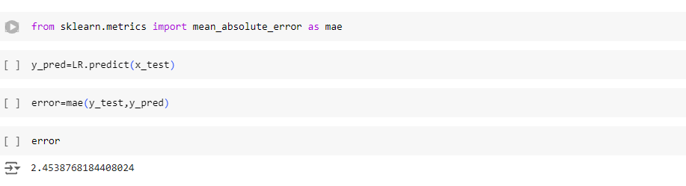
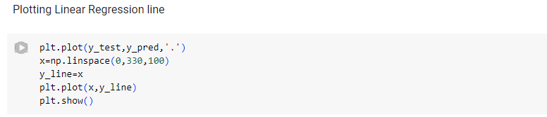
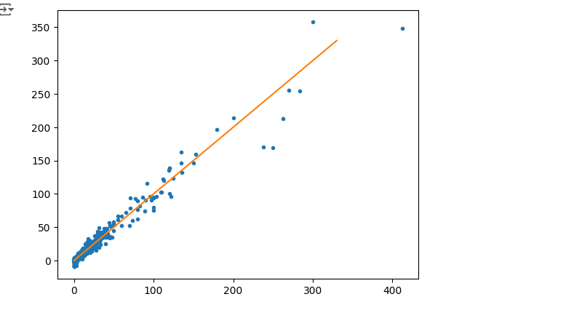

IMPORTING PICKLE
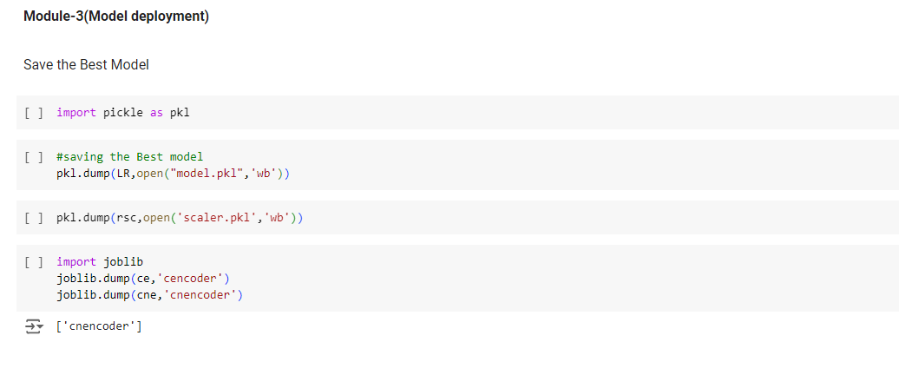

6.RESULTS
HOME PAGE
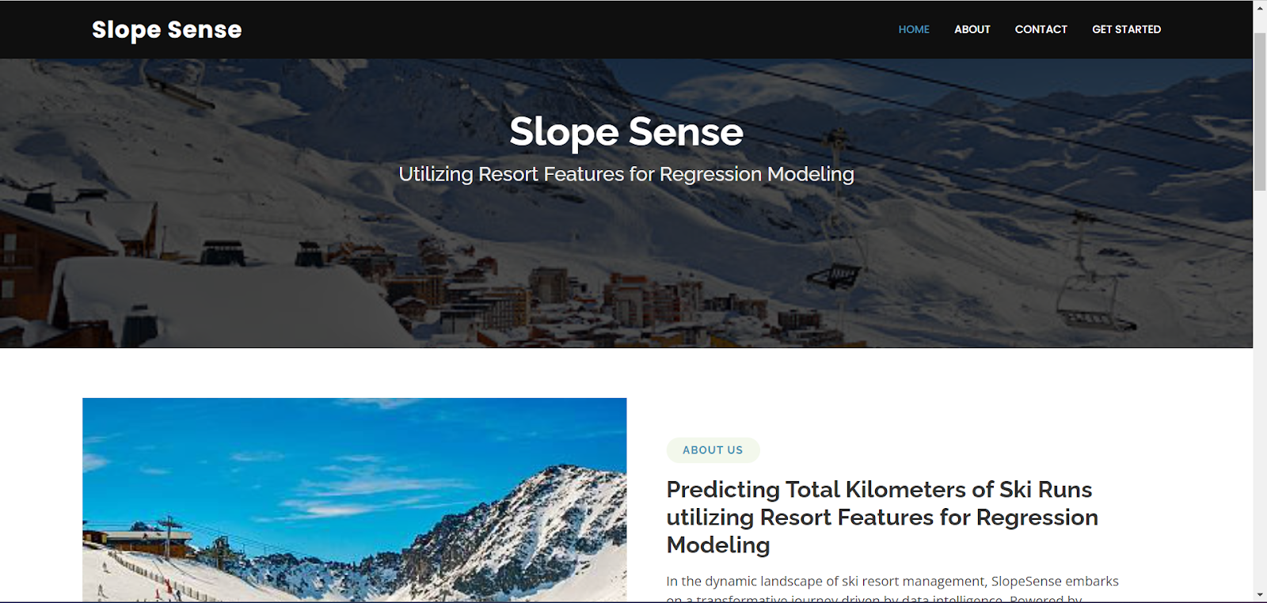

PREDICT PAGE
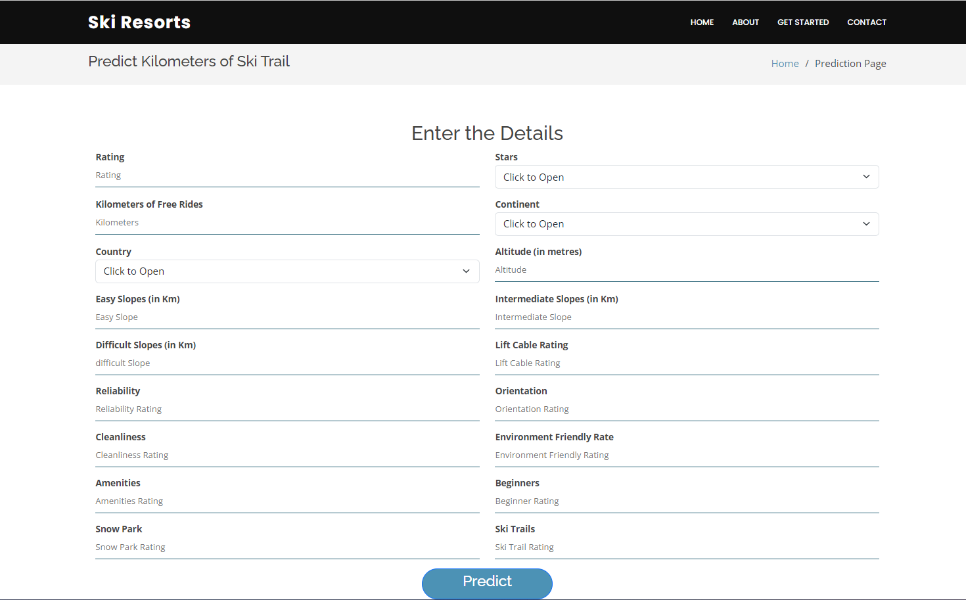

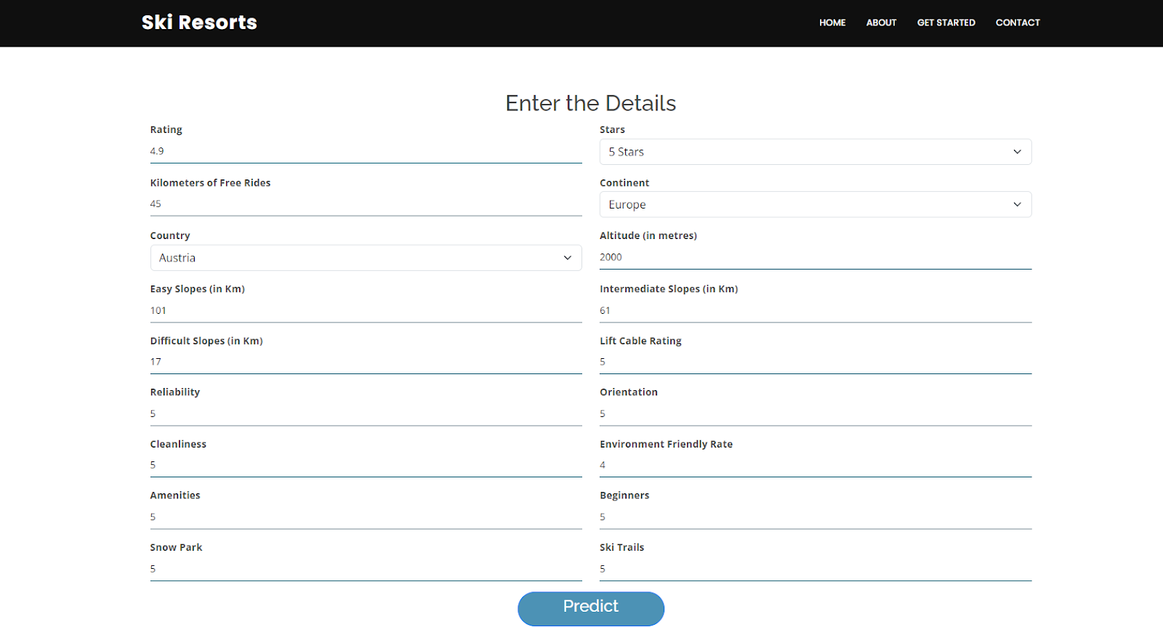

RESULT PAGE

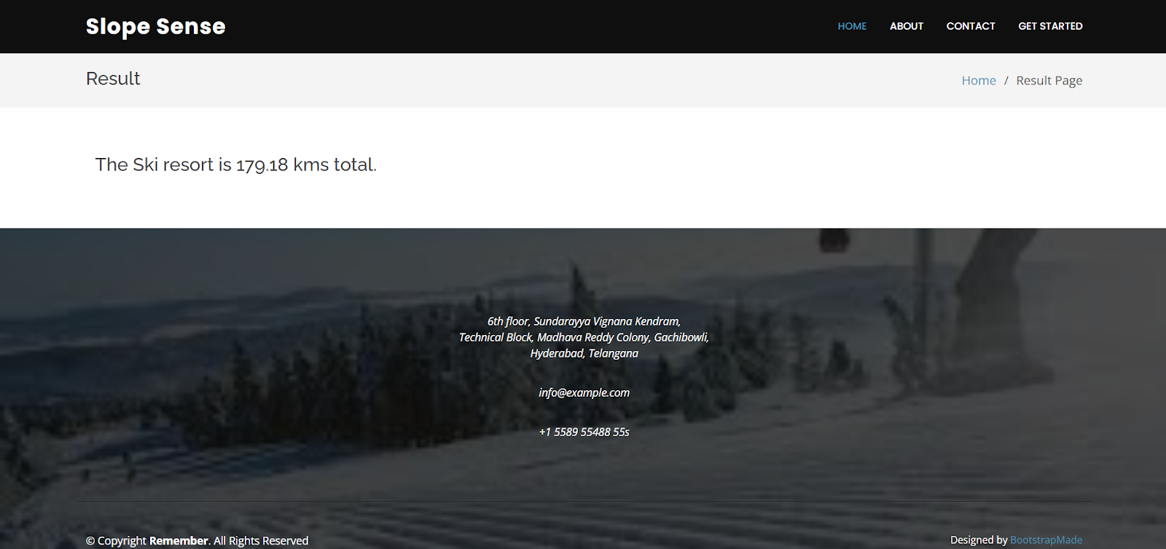

7.ADVANTAGES AND DISADVANTAGES
Advantages
1. Predictive Power:
- Slope sense can help identify how different resort features impact outcomes like visitor satisfaction or revenue, enhancing predictive accuracy.
2. Insight into Relationships:
- It allows for a clear understanding of the relationships between variables, helping stakeholders make informed decisions.
3. Feature Importance:
- Regression modeling can rank the significance of various resort features, guiding resource allocation and strategic planning.
4. Quantitative Analysis:
- Provides quantitative metrics to assess the effect of changes in resort features, facilitating data-driven decision-making.
5. Scenario Analysis:
- Enables simulation of various scenarios to see how changes in features might influence overall performance.
Disadvantages
1. Assumptions:
- Regression analysis relies on several assumptions (linearity, independence, homoscedasticity) that, if violated, can lead to misleading results.

2. Overfitting:
There is a risk of overfitting the model to historical data, which may not generalize well to future scenarios.
3. Complexity:
- Analyzing multiple features can lead to complex models that are difficult to interpret, especially for stakeholders without statistical expertise.
4• Data Sensitivity:
- The results can be sensitive to outliers or influential points, which can skew findings and lead to incorrect conclusions
- .
- 5.Limited Scope:
- Regression may not capture all relevant factors influencing resort performance, such as external market conditions or competitor actions.

8.APPLICATIONS

1. Visitor Satisfaction Analysis:
- Assess how resort features (e.g., amenities, location) affect guest satisfaction scores, helping to prioritize improvements.
2. Revenue Forecasting:
- Model the relationship between resort features (like room types, dining options) and revenue to predict future income based on changes.
3. Market Segmentation:
- Analyze how different features attract various demographic groups, enabling targeted marketing strategies.
4. Customer Behavior Insights:
- Understand the impact of resort features on customer booking patterns, length of stay, and repeat visits.
5. Pricing Strategy Optimization:
- Utilize regression to identify how different features influence pricing strategies, helping to set competitive rates.
6. Resource Allocation:
- Inform management decisions on where to invest in enhancements by quantifying the potential impact of specific resort features.

7.Competitor Analysis:
- Compare the influence of features across competing resorts to identify strengths and weaknesses in the market.
8. Event Planning and Management:
- Analyze how different event features (size, location) affect attendance and satisfaction for conferences or weddings held at the resort.
9. Sustainability Impact Assessment:
- Evaluate how environmentally friendly practices or features influence guest choices and satisfaction.
10. Seasonal Trend Analysis:
- Model how seasonal changes affect the importance of various resort features, helping to optimize offerings throughout the year.

9. CONCLUSION

Slope sense utilizing resort features in regression modeling provides valuable insights into the relationships between various attributes and outcomes. By leveraging these analyses, resorts can enhance decision-making processes, optimize resource allocation, and improve guest satisfaction. Understanding how different features impact key metrics enables more effective strategic planning and targeted marketing, ultimately leading to increased profitability and a competitive edge in the hospitality industry. However, careful attention to model assumptions and potential limitations is essential to ensure accurate and actionable results.

10. FUTURE SCOPE
1. Integration of Machine Learning:
- Combining regression with machine learning techniques to enhance predictive accuracy and model complexity.
2. Real-Time Analytics:
- Implementing real-time data collection and analysis for dynamic adjustments to strategies based on current trends.
3. Guest Experience Personalization:
- Utilizing regression modeling to tailor personalized experiences based on individual preferences and behaviors.
4. Sustainability Metrics:
- Incorporating environmental impact features into models to assess and promote sustainable practices within resorts.
5. Cross-Feature Analysis:
- Exploring interactions between different resort features to understand compound effects on outcomes more thoroughly.
6. Expanded Data Sources:
- Leveraging social media, reviews, and external data to enrich models and capture a broader context of guest preferences.
7. Predictive Maintenance:
- Using regression to forecast maintenance needs for resort features, enhancing operational efficiency and guest satisfaction.
8. Scenario Planning:
- Developing advanced scenario analysis tools to simulate the effects of potential changes in the market or resort features.
9. Integration with Customer Relationship Management (CRM):
- Linking regression insights with CRM systems to improve targeted marketing and customer engagement strategies.
10. Benchmarking Against Competitors:
- Establishing frameworks for comparing resort feature impacts across competitors to identify industry best practices.

11. BIBILOGRAPHY
1. Keller, K. L., & Kotler, P. (2016). Marketing Management. Pearson Education.
- Discusses marketing strategies and consumer behavior relevant to the hospitality industry.
2. Field, A. (2018). Discovering Statistics Using IBM SPSS Statistics. Sage Publications.
- Provides insights into regression analysis techniques and their applications.
3. Hair, J. F., Anderson, R. E., Babin, B. J., & Black, W. C. (2019). Multivariate Data Analysis. Pearson.
- Covers advanced statistical techniques, including regression modeling, applicable to various fields.
4. Baker, M. J., & Crompton, J. L. (2000). Identifying BC's Tourism Product Attributes: An Analysis of the Product's Importance. Tourism Management, 21(4), 487-498.
- Explores product attributes and their significance in tourism, relevant for feature analysis.
5. Sharma, A., & Thomas, H. (2016). Hospitality and Tourism Research. International Journal of Hospitality Management, 34, 119-123.
- Investigates the application of statistical methods in hospitality research.
6. Chen, C. F., & Tsai, D. C. (2007). How Destination Image and Cultural Heritage Influence Tourists’ Attitude and Behavior.International Journal of Tourism Research, 9(5), 401-414.
- Analyzes how resort features impact tourist behaviors through regression analysis
7. Montgomery, D. C., & Peck, E. A. (2019).Introduction to Linear Regression Analysis. Wiley.
- A comprehensive guide to regression techniques, including practical applications.
8. Gunter, U., & Önder, I( 2019). Hotel Management and Operations. Cengage Learning.
- Discusses operational strategies and the significance of resort features.
9. Song, H., & Li, G. (2008). The Impact of Tourism on Economic Growth: A Panel Data Approach. Tourism Economics, 14(4), 669-691.
- Provides insights into the economic impacts of tourism features.
10. Ritchie, J. R. B., & Crouch, G. I.(2003). The Competitive Destination: A Sustainable Tourism Perspective. CABI Publishing.
- Discusses competitive strategies in tourism, relevant to regression analysis in resort features.

12.APPENDIX
Model building :
1)Dataset
2)Google colab and VS code Application Building
1. HTML file (Index file, Predict file,predict page file )
1. CSS file
2. Models in pickle format
SOURCE CODE:
INDEX.HTML
<!DOCTYPE html>
<html lang="en">
<head>
<meta charset="UTF-8">
<meta name="viewport" content="width=device-width, initial-scale=1.0">
<title>Slope Sense</title>
<style>
body {
font-family: Arial, sans-serif;
margin: 0;
padding: 0;
}
.header {
background: url('https://himalayansteps.com/wp-content/uploads/2018/06/himalayas-960x636.jpg') no-repeat center center/cover;
height: 300px;
color: rgb(0, 7, 10);
text-align: center;
display: flex;
justify-content: center;
align-items: center;
flex-direction: column;
}
.header h1 {
margin: 0;
font-size: 3em;
}
.header p {
margin: 0;
font-size: 1.2em;
}
.nav {
background-color: black;
overflow: hidden;
}
.nav a {
float: right;
display: block;
color: white;
text-align: center;
padding: 14px 16px;
text-decoration: none;
}
.nav a:hover {
background-color: #ddd;
color: black;
}
.content {
padding: 20px;
text-align: center;
}
.about-section {
display: flex;
justify-content: center;
align-items: center;
flex-direction: column;
}
.about-section img {
width: 100%;
height: auto;
max-width: 800px;
}
.about-section h2 {
font-size: 2em;
margin-top: 20px;
}
.about-section p {
max-width: 800px;
text-align: left;
margin-top: 20px;
}
</style>
</head>
<body>
<div class="header">
<h1>Slope Sense</h1>
<p>Utilizing Resort Features for Regression Modeling</p>
<a href="http://127.0.0.1:5500/predict.html"
class="btn">get started</a>
</div>
<div class="nav">
<a href="/predict_page">GET STARTED</a>
<a href="#contact">CONTACT</a>
<a href="#about-section">ABOUT</a>
<a href="/">HOME</a>
</div>
<div class="content">
<div class="about-section">
<img src="https://static.toiimg.com/thumb/msid-94850960,width-748,height-499,resizemode=4,imgsize-221796/.jpg" alt="Ski Resort">
<h2>Predicting Total Kilometers of Ski Runs utilizing Resort Features for Regression Modeling</h2>
<p>
In the dynamic landscape of ski resort management, SlopeSense embarks on a transformative journey
driven by data intelligence. Powered by innovative regression modeling techniques, we predict
the total kilometers of ski runs, helping resorts optimize their offerings and enhance the
overall experience for their guests.
</p>
</div>
</div>
</body>
</html>
PREDICT.HTML
<!DOCTYPE html>
<html lang="en">
<head>
<meta charset="UTF-8">
<meta name="viewport" content="width=device-width, initial-scale=1.0">
<title>Predict Kilometers of Ski Trail</title>
<style>
body {
font-family: Arial, sans-serif;
margin: 0;
padding: 0;
background-color: #f8f8f8;
}
.header {
background-color: #000;
color: #fff;
padding: 15px;
text-align: center;
}
.container {
max-width: 800px;
margin: 50px auto;
background-color: #fff;
padding: 20px;
border-radius: 8px;
box-shadow: 0 0 10px rgba(0,0,0,0.1);
}
.title {
text-align: center;
margin-bottom: 30px;
}
.form-group {
display: flex;
justify-content: space-between;
margin-bottom: 15px;
}
.form-group label {
flex: 1;
margin-right: 10px;
}
.form-group input, .form-group select {
flex: 2;
padding: 10px;
border: 1px solid #ccc;
border-radius: 4px;
}
.form-group select {
appearance: none;
}
.form-group .flex-1 {
flex: 1;
}
.form-group .flex-2 {
flex: 2;
}
.predict-btn {
text-align: center;
margin-top: 30px;
}
.predict-btn button {
padding: 10px 20px;
background-color: #007bff;
color: #fff;
border: none;
border-radius: 4px;
cursor: pointer;
font-size: 16px;
}
.predict-btn button:hover {
background-color: #0056b3;
}
</style>
</head>
<body>
<div class="header">
<h1>Ski Resorts</h1>
</div>
<div class="container">
<div class="title">
<h2>Predict Kilometers of Ski Trail</h2>
</div>
<form>
<div class="form-group">
<label for="rating">Rating</label>
<input type="text" id="rating" name="rating">
</div>
<div class="form-group">
<label for="freeRides">Kilometers of Free Rides</label>
<input type="text" id="freeRides" name="freeRides">
</div>
<div class="form-group">
<label for="country">Country</label>
<select id="country" name="country">
<option value="select">select</option>
<option value="India">India</option>
<option value="America">America</option>
<option value="Africa">Africa</option>
<option value="Australia">Australia</option>
<option value="New York">New York</option>
</select>
</div>
<div class="form-group">
<label for="easySlopes">Easy Slopes (in Km)</label>
<input type="text" id="easySlopes" name="easySlopes">
</div>
<div class="form-group">
<label for="difficultSlopes">Difficult Slopes (in Km)</label>
<input type="text" id="difficultSlopes" name="difficultSlopes">
</div>
<div class="form-group">
<label for="reliability">Reliability</label>
<input type="text" id="reliability" name="reliability">
</div>
<div class="form-group">
<label for="cleanliness">Cleanliness</label>
<input type="text" id="cleanliness" name="cleanliness">
</div>
<div class="form-group">
<label for="amenities">Amenities</label>
<input type="text" id="amenities" name="amenities">
</div>
<div class="form-group">
<label for="snowPark">Snow Park</label>
<input type="text" id="snowPark" name="snowPark">
</div>
<div class="form-group">
<label for="stars">Stars</label>
<select id="stars" name="stars">
<option value="select">select</option>
<option value="1">1</option>
<option value="2">2</option>
<option value="3">3</option>
<option value="4">4</option>
<option value="5">5</option>
</select>
</div>
<div class="form-group">
<label for="continent">Continent</label>
<select id="continent" name="continent">
<option value="select">select</option>
<option value="Asia">Asia</option>
<option value="Africa">Africa</option>
<option value="Antarctica">Antarctica</option>
<option value="Australia">Australia</option>
<option value="Europe">Europe</option>
<option value="South America">South America</option>
<option value="North America">South America</option>
</div>
<div class="form-group">
<label for="altitude">Altitude (in metres)</label>
<input type="text" id="altitude" name="altitude">
</div>
<div class="form-group">
<label for="intermediateSlopes">Intermediate Slopes (in Km)</label>
<input type="text" id="intermediateSlopes" name="intermediateSlopes">
</div>
<div class="form-group">
<label for="liftCable">Lift Cable Rating</label>
<input type="text" id="liftCable" name="liftCable">
</div>
<div class="form-group">
<label for="orientation">Orientation</label>
<input type="text" id="orientation" name="orientation">
</div>
<div class="form-group">
<label for="environment">Environment Friendly Rate</label>
<input type="text" id="environment" name="environment">
</div>
<div class="form-group">
<label for="beginners">Beginners</label>
<input type="text" id="beginners" name="beginners">
</div>
<div class="form-group">
<label for="skiTrails">Ski Trails</label>
<input type="text" id="skiTrails" name="skiTrails">
</div>
<div class="predict-btn">
<a href="result.html">Predict</a>
</div>
</form>
</div>
</body>
</html>
PREDICTPAGE.HTML
<!DOCTYPE html>
<html lang="en">
<head>
<meta charset="UTF-8">
<meta name="viewport" content="width=device-width, initial-scale=1.0">
<title>Result Page</title>
<style>
body {
font-family: Arial, sans-serif;
margin: 0;
padding: 0;
background-color: #2a148077;
}
.header {
background-color: #000;
color: #fff;
padding: 15px;
text-align: center;
}
.header h1 {
margin: 0;
}
.navbar {
text-align: right;
padding: 10px;
background-color: #fff;
border-bottom: 1px solid #ddd;
}
.navbar a {
margin: 0 15px;
text-decoration: none;
color: #000;
}
.breadcrumb {
padding: 15px;
background-color: #eee;
border-bottom: 1px solid #ddd;
}
.breadcrumb a {
text-decoration: none;
color: #007bff;
}
.container {
max-width: 900px;
margin: 50px auto;
background-color: #fff;
padding: 20px;
border-radius: 8px;
box-shadow: 0 0 10px rgba(0,0,0,0.1);
text-align: center;
}
.container p {
font-size: 18px;
margin: 0;
}
.footer {
background-color: #000;
color: #fff;
padding: 20px;
text-align: center;
}
.footer p {
margin: 5px 0;
}
.footer a {
color: #007bff;
text-decoration: none;
}
</style>
</head>
<body>
<div class="header">
<h1>Slope Sense</h1>
</div>
<div class="navbar">
<a href="/">HOME</a>
<a href="/predict_page">ABOUT</a>
<a href="#footer">CONTACT</a>
<a href="#">GET STARTED</a>
</div>
<div class="breadcrumb">
<a href="#">Home</a> / <span>Result Page</span>
</div>
<div class="col-lg-8">
<form id="faq" data-form onsubmit="return calculatetrip()">

</form>
<div class="result-container">
<div class="result-text">
<h1>Result</h1>
<p class="mb-0"><strong>{{ prediction_text }}</strong></p>
</div>
</div>
<div class="footer">
<p>6th floor, Sundarayya Vignana Kendram,<br>
Technical Block, Madhava Reddy Colony, Gachibowli,<br>
Hyderabad, Telangana</p>
<p>info@example.com</p>
<p>+1 5589 55488 55s</p>
<p>© Copyright <strong>Remember</strong>. All Rights Reserved</p>
<p>Designed by <a href="#">BootstrapMade</a></p>
</div>
</body>
</html>
APP.PY
import pickle
from flask import Flask, render_template, request
import numpy as np
import pandas as pd
app = Flask(_name_, template_folder='Template')
model = pickle.load(open('model.pkl','rb'))
@app.route('/')
def Home():
return render_template('home.html')
@app.route('/predict_page')
def predict():
return render_template("predict.html")
@app.route('/predict', methods=['GET','POST'])
def prediction():
rate=float(request.form["Rate"])
star=float(request.form["Stars"])
fkms=float(request.form["freekms"])
cont=float([request.form["Continent"]])[0]
count=float([request.form["Country"]])[0]
alt=float(request.form["altitude"])
easy=float(request.form["easy"])
intermediate=float(request.form["intermediate"])
difficult=float(request.form["difficult"])
lc=float(request.form["lcrating"])
rel=float(request.form ["reliabilty"])
orien=float(request.form["orientation"])
clean=float(request.form["clean"])
env=float(request.form["environment"])
amen=float(request.form["amenities"])
beg=float(request.form["beginners"])
spark=float(request.form["snowpark"])
strail=float(request.form["skitrail"])
features_values = np.array([[rate, star, fkms, cont, count, alt, easy, intermediate, difficult,lc,
rel, orien, clean, env, amen, beg, spark, strail ]]
df = pd.DataFrame(features_values, columns= ['rate', 'star', 'fkms', 'cont', 'count', 'alt', 'easy', 'intermediate', 'difficult','lc',
'rel', 'orien', 'clean', 'env', 'amen', 'beg', 'spark', 'strail'])
print(df)
y_pred = model.predict(df)
result="The Ski resort is "+str(round (y_pred[0] [0],2))+" kms total."
return render_template("predictionpage.html", prediction_text=result)
if _name_ == "_main_":
app.run(debug=True , port=5000)

